# Thinfinity Password Change Procedure

To change the password for Thinfinity, please follow these steps

1. Open the website <https://app.eventsair.com/>
2. Log in with your current username and password
3. Click on the collapsible panel at the top of the screen



1. Click on the “Actions” button that is revealed



1. Click on the “Send Keys…” menu item

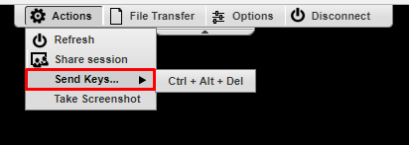

1. Click on the “Ctrl + Alt + Del” menu item

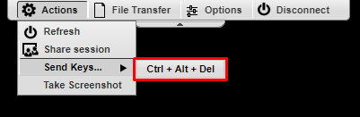

1. Click on the “Change a password” option in the new menu

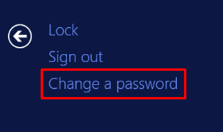

1. You can now change the password

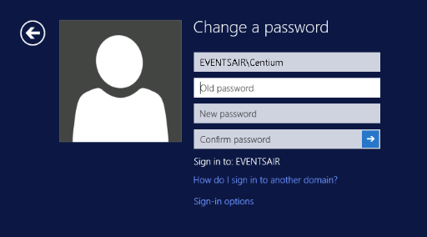

The new password must meet the following complexity rules:

* At least one upper case letter
* At least one lower case letter
* At least one number
* At least one special character – i.e. (!~@(#*&)
* A minimum length of 7
* Can only be changed once per day
* Can’t use a previously used password

The password needs to be updated every 90 days to stay valid, otherwise this will need to be reset by the EventsAIR team (Average 1 business day turnaround).